App: GPS: Phase #1

Date: Feb 27th, 2023  
Domain: <https://gps.brickmmo.com>

GitHub: <https://github.com/codeadamca/brickmmo-gps>

# Application Purpose:

This application will use the Pixy2 AI camera to track coordinates of seven LEGO™ robots.

The end result will allow for a data visualization app using the LEGO™ map and locations of robots:

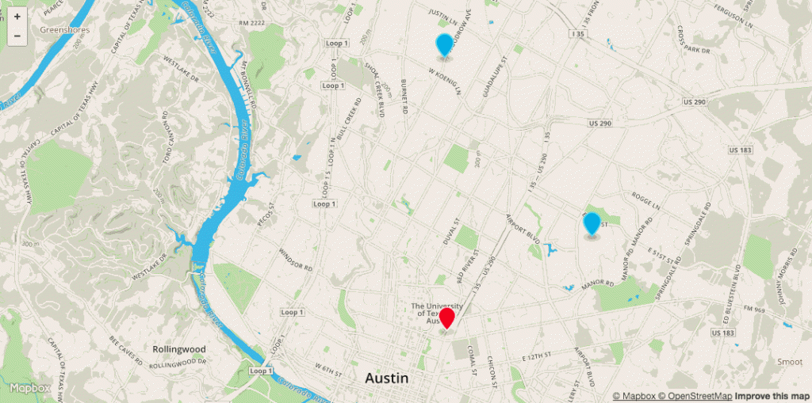

# Front-End:

Front end facing application will include the following features:

* A real-time map indicating the current location of each of the seven robots
* Possibly a slider to pan through recent history
* Other features determined by group

Frontend design may look something like this:

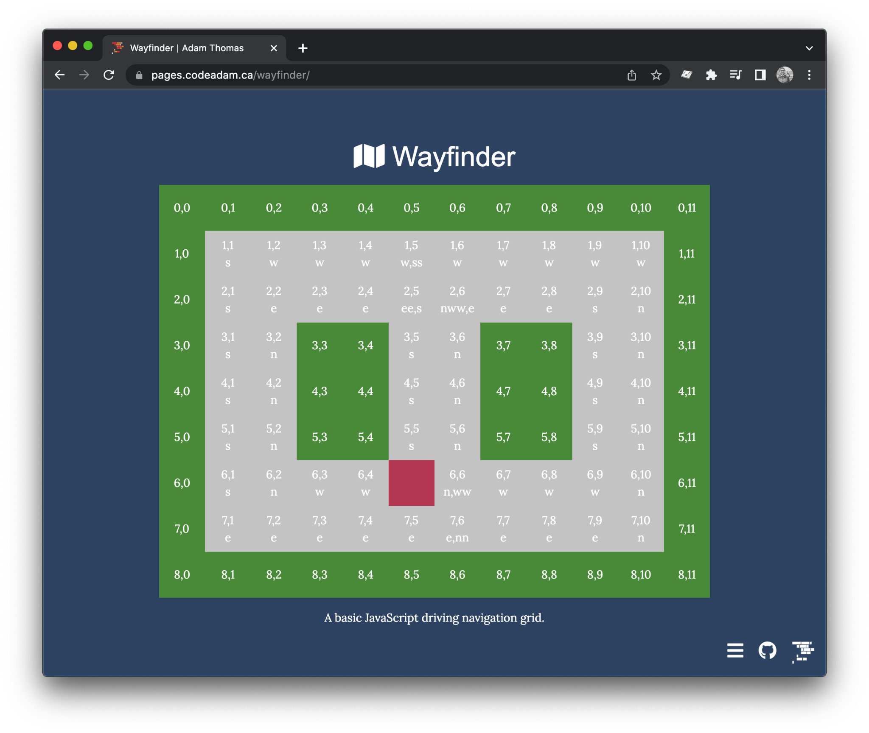

# Back-End:

Application will include a control panel to achieve the following:

* Login to control panel
* Manage the seven robots
* View position history

This application will also require a Python codeset residing on a Pixy2/EV3 to update robot positions. Updates will happen once per second. Update will use the /api/position/{id} endpoint.

# API:

Application API will include the following API calls:

| **Method** | **Endpoint** | **Description** | |
| --- | --- | --- | --- |
| GET | /api/robots | Return a list of the seven robots including ID, current position, last movement date/dime, colour, and profile data. | |
| GET | /api/position/{id} | A quick call to retrieve ONLY the current coordinates of the specified robot.  **Parameters:**  id (required): a method of identifying a robot using colour or record ID. | |
| GET | /api/history/{id} | A detailed report of a single robot profile, location, and last 100 positions.  **Parameters:**  id (required): a method of identifying a robot using colour or record ID.  from_date and to_date (optional): if both are specified, the API will return all tracking between the two dates. | |
| POST | /api/position/{id} | A quick API endpoint that will primarily be called by the Python application to update a robot's location.  **Parameters:**  id (required): a method of identifying a robot using colour or record ID. | |